Delta Module 1 – Pre-interview Task
First name | Click or tap here to enter text. | Surname | Click or tap here to enter text.

Reasons for applying
Please outline briefly why you are interested in the Delta Module 1 course and how it might benefit you. Try to be specific.
Click or tap here to enter text.

Strengths and weaknesses
Consider what your strengths and weaknesses in relation to the course are. You may consider your experience, previous education/training, language awareness, reading done, teaching techniques, classroom management skills, teacher qualities, personal qualities etc.
Click or tap here to enter text.

Knowledge about language
Please answer the following questions. Try not to refer to any sources, i.e. rely simply on your knowledge. It’s important that we can assess your knowledge accurately to ensure if you’re accepted, you can cope with the course.
1. Provide the term for each definition.
a the use of grammatical and lexical means to achieve connected text, either spoken or written. These include: reference words e.g. this, the, it; linkers e.g. However, and topic-related lexis
Click or tap here to enter text.
b knowledge of not only if something is formally possible in a language, but also whether it is feasible, appropriate, or done in a particular speech community. This includes grammatical, sociolinguistic, discourse and other competences.
Click or tap here to enter text.
c the extent to which the items in a test reflect the essential aspects of the theory on which the test is based.
Click or tap here to enter text.
d a speech sound produced by narrowing the distance between two articulators so that the airstream is not completely closed but obstructed enough that a turbulent airflow is produced, as in the English /f/, /v/, /s/ and /z/ sounds in enough, valve, sister, and zoo.
Click or tap here to enter text.
e restrictions on how words can be used together, for example which prepositions are used with particular verbs, or which verbs and nouns are used together.
Click or tap here to enter text.
f the process of adding an affix to a word or changing it in some other way according to the rules of the grammar of a language.
Click or tap here to enter text.
2. Provide a definition and an appropriate brief example or illustration of each of the terms below.
a lexical approach
Click or tap here to enter text.
b colligation
Click or tap here to enter text.
c diagnostic test
Click or tap here to enter text.
d genre
Click or tap here to enter text.
3. Please answer the questions below the text

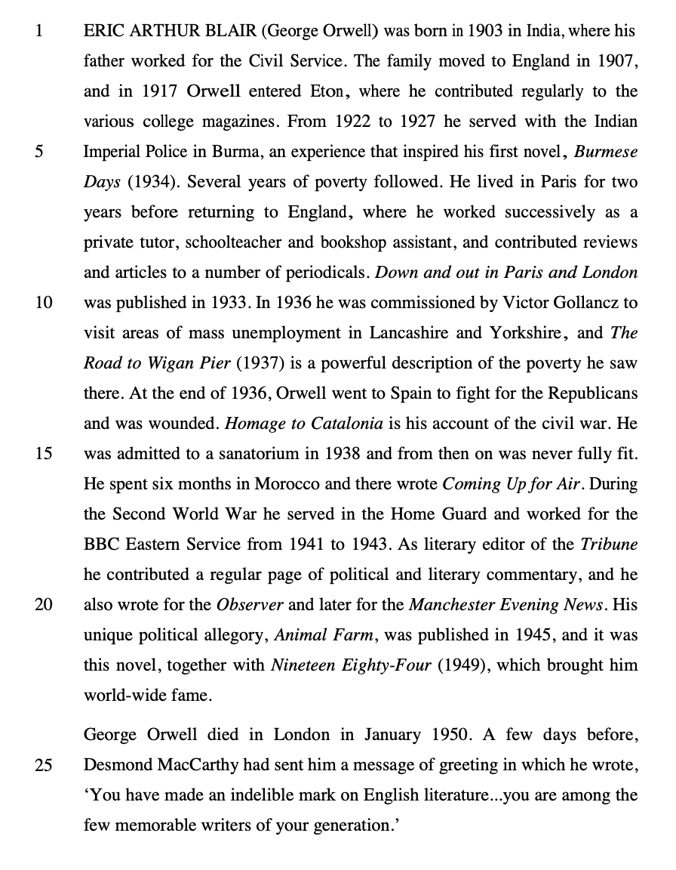

a Comment on the form and meaning/use of the words in bold as they are used in the text.
i. ERIC ARTHUR BLAIR (George Orwell) was born in 1903 (line 1)
Click or tap here to enter text.
ii. He also wrote for the Observer (lines 19-20)
Click or tap here to enter text.
iii. A few days before, Desmond MacCarthy had sent him a message of greeting (lines 24-25)
Click or tap here to enter text.
vi. you have made an indelible mark on English literature (line 26)
Click or tap here to enter text.
b Comment on the use of relative clauses and relative pronouns in the following extracts in the following extracts from the text.
i. Orwell entered Eton, where he contributed regularly to the various college magazines. (lines 3-4)
Click or tap here to enter text.
ii. Desmond MacCarthy had sent him a message of greeting in which he wrote (line 25)
Click or tap here to enter text.

c Comment on the features of connected speech likely to occur in the following:
• you are among the few memorable writers of your generation. (lines 26-27)
Click or tap here to enter text.

4. Methodology
Many teachers believe that they should at all times reduce their own talking time and increase that of their students. What reasons are there for reducing teacher talking time and increasing student talking time? How do learners benefit from teacher talking time in a lesson?
Click or tap here to enter text.

